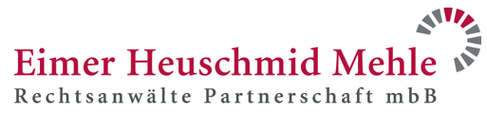

Public Transport For The Bonn Conference

1. Bus and train connections between the conference hotel and Cologne Airport:
Bus SB 60 towards Bonn Central Station
Boarding at Cologne/Bonn Airport Terminal 2 (bus), Cologne – exit at Brüdergasse/Bertha-von-Suttner-Platz“, Bonn – 10-minute walk
Regional train RB 26 towards Koblenz Hauptbahnhof (main station)
Boarding: Cologne/Bonn Airport, Cologne – exit: Station Bonn-Beuel – Connection: Bus 609 towards Hardthöhe/Südwache – exit: “Brüdergasse/Bertha-von-Suttner-Platz“ – 10 minute walk

2. Bus and train connections between the conference hotel and the main railway station:
Underground 16, 63 or 66 towards Bad Honnef or Bad Godesberg
Board at “Bonn Central Station“ underground station – exit at “Universität/Markt“– 5 minute walk

3.) Bus and train connections between the conference hotel and Eimer Heuschmid Mehle Rechtsanwälte (For Thursday evening reception):
S-Bahn 66 towards Bad Honnef:
Board at “Universität/Markt“ – exit at “Ramersdorf“, Bonn – 10 minutes' walk
Bus 606 towards Ramersdorf:
Board at “Brüdergasse/Bertha-von-Suttner-Platz“– exit at “Konrad-Zuse-Platz“, Bonn – 2 minute' walk
Bus 607 towards Ramersdorf:
Board at “Brüdergasse/Bertha-von-Suttner-Platz“– exit at “Bonner Bogen“, Bonn – 2 minute' walk

