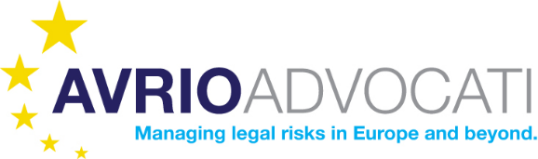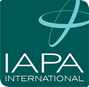

JOINT STATEMENT
on
Forming Strategic Partnership

It is our great pleasure to announce that the International Board of IAPA and Avrio Advocati unanimously approved a Memorandum of Understanding for a Strategic Partnership between IAPA and Avrio Advocati. Both of our Boards see a considerable potential in this Strategic Partnership and are confident that our two organizations will bring true value to each other and to its’ members.
IAPA is a leading global association of independent audit, tax, legal, advisory, financial, immigrational and technology services firms. Each IAPA member is an independent firm controlled or owned by individuals holding internationally recognized accountancy qualifications. Key to IAPA’s success is the value placed on personal service offering effective, sustainable business solutions at an individual level, as well as the strength of support between global members. You can find further information on IAPA’s website www.iapa.net.
Avrio Advocati is a global network of law firms with the main object to provide international business opportunities for it’s members, to facilitate networking between member firms and their partners, to develop exchange of professional know-how and to foster legal cooperation cross-border. All of the Avrio Advocati activity is dedicated to facilitate cross border legal work of our members on world-wide bases. You can find further information on Avrio Advocati on www.avrioadvocati.com.
Some of the key elements of the relationship constituted by this Memorandum of Understanding:
- The relationship shall be described as a “Strategic Partnership”;
- From a legal / constitutional point of view, the relationship will be informal, non-exclusive and non-binding;
- The objective of the Strategic Partnership is to grow business referrals for members of both organizations and to widen the professional penetration of each organization. Both organisations shall share lists of members (as updated from time to time) showing names and contact persons of their respective organisations to help facilitate visits and referrals;
- Mechanics of the relationship would include:

- Conferences: Members of each organisation shall be entitled to attend the conferences of the other organisation (except the AGM aspects). Such attendees shall pay a fee to the host organization (in addition to social program costs) . Such a fee shall be determined for each of the future conferences respectively.

Each organisation will endeavour to involve a member of the other organisation in one panel or break-out session per conference: this will raise the profile of the relationship to members of both organisations. Three possible subjects for common sessions are corporate finance, succession for family businesses and family law.

- Website & publications: Each organisation’s website will make reference to the existence of this Strategic Partnership. Each organisation will endeavour to provide a minimum of 3 [three] blog pieces or articles per year for publication by the other in their member newsletters and website.

- Member-to-member visits: Each organisation will encourage individual members to visit and get to know the members of the other’s organisation in their own country or region, and to visit member firms of
the other’s organisation when in country.

This Strategic Partnership creates a platform where lawyers and accountants from the same jurisdictions, but at global level as well, would market together on an international basis. At the same time, the Partnership would create a level play field where lawyers and accountants may compete healthily with the global and accounting brands. It is our strong belief that everybody is a winner here – and we cordially invite each and every of our members to grasp many opportunities this collaboration provides and grow their businesses and both of our organizations.

On behalf of On behalf of
Avrio Advocati AISBL IAPA

_______________________ _______________________
Mr. Philip Gilliland Mr. Martin Clapson
President Global Chairman

